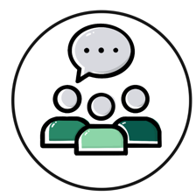
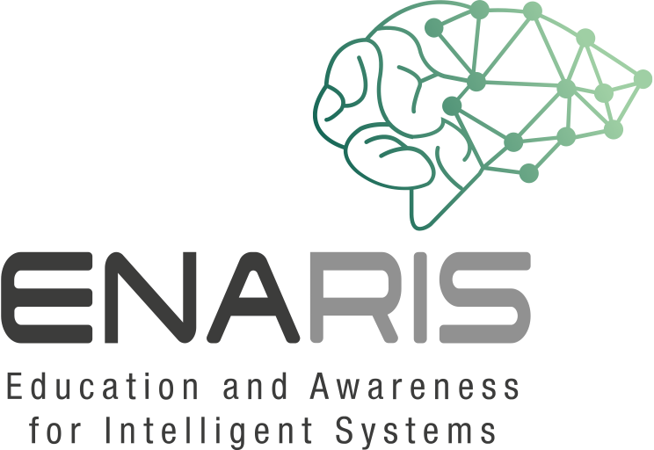
Let's talk about Chatbots!

Why are chatbots used? What are their advantages? Discuss in groups!

Have you already come into contact with chatbots? If so, for what purpose?

What problems or dangers could there be with chatbots?

Possible further questions:
Chatbots are also used with lonely people or people with mental health problems. Do you think that makes sense or is well accepted by those affected? What problems could arise when lonely people interact more (or only) with chatbots?

With some conversations you don't know exactly whether you're talking to a human being or a chatbot. Should chatbots be clearly marked as such?

